9.2 corrections

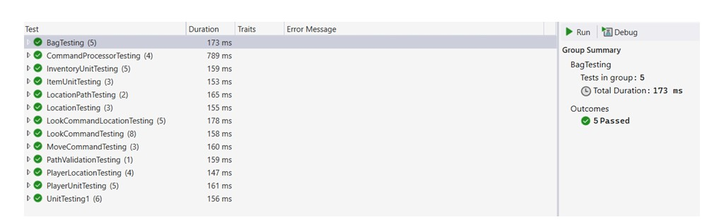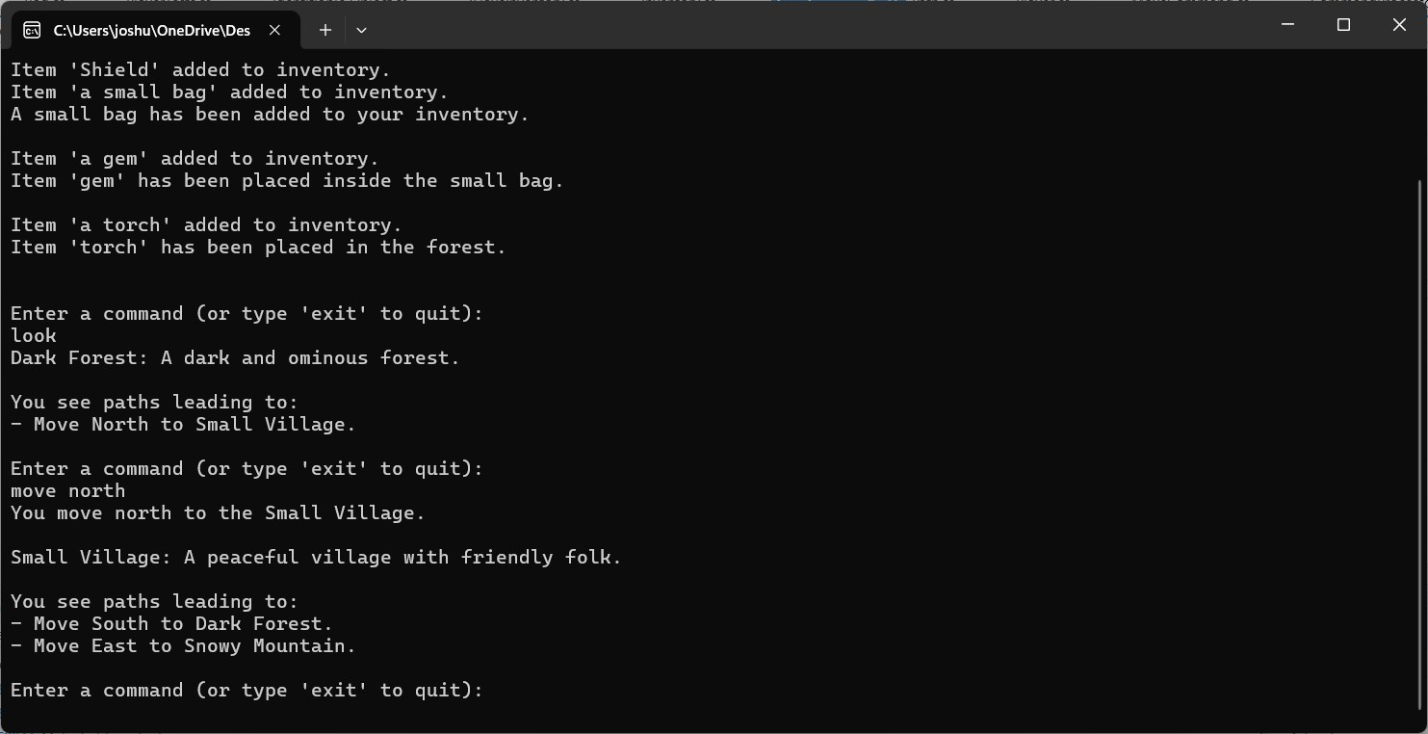

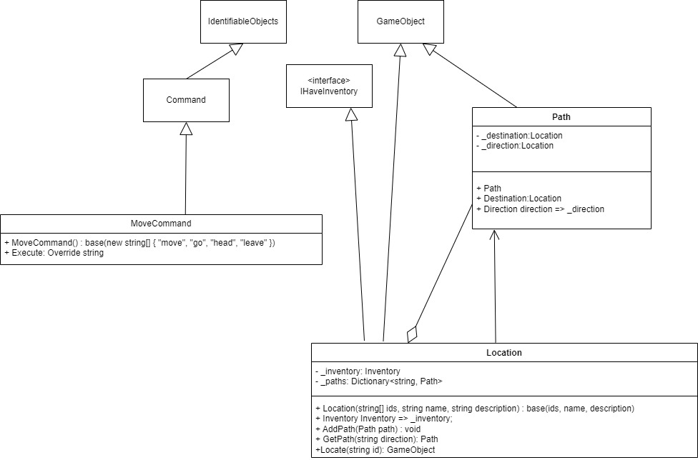

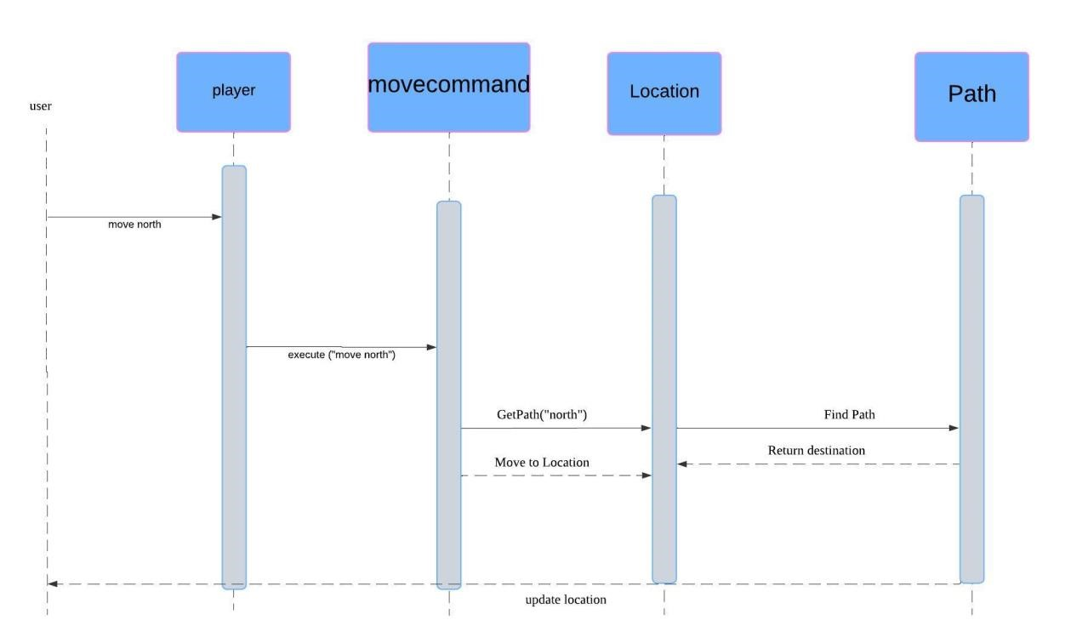

Program.cs: using System; using SwinAdventure;

class Program

{

static void Main(string[] args)

{

// Step 1: Set up the player with their name and description. Console.Write("Enter your player's name: "); string playerName = Console.ReadLine();

Console.Write("Enter a description for your player: "); string playerDescription = Console.ReadLine();

Player player = new Player(playerName, playerDescription);

Console.WriteLine($"\nWelcome, {playerName}, {playerDescription}!\n");

// Step 2: Set up locations and paths

Location forest = new Location(new string[] { "forest" }, "Dark Forest", "A dark and ominous forest.");

Location village = new Location(new string[] { "village" }, "Small Village", "A peaceful village with friendly folk.");

Location mountain = new Location(new string[] { "mountain" }, "Snowy Mountain", "A tall, snowy mountain peak.");

Location lake = new Location(new string[] { "lake" }, "Crystal Lake", "A clear, sparkling lake.");

// Connect locations with paths forest.AddPath(new SwinAdventure.Path(SwinAdventure.Path.Direction.North, village)); village.AddPath(new SwinAdventure.Path(SwinAdventure.Path.Direction.South, forest)); village.AddPath(new SwinAdventure.Path(SwinAdventure.Path.Direction.East, mountain)); mountain.AddPath(new SwinAdventure.Path(SwinAdventure.Path.Direction.West, village)); mountain.AddPath(new SwinAdventure.Path(SwinAdventure.Path.Direction.North, lake)); lake.AddPath(new SwinAdventure.Path(SwinAdventure.Path.Direction.South, mountain));

// Step 3: Place the player in the initial location player.Location = forest;

// Step 4: Add some items to the player’s inventory

Item sword = new Item(new string[] { "sword" }, "Sword", "A sharp, shiny sword."); Item shield = new Item(new string[] { "shield" }, "Shield", "A sturdy wooden shield."); player.Inventory.Put(sword); player.Inventory.Put(shield);

Bag smallBag = new Bag(new string[] { "bag", "small bag" }, "a small bag", "A small leather bag."); player.Inventory.Put(smallBag);

Console.WriteLine("A small bag has been added to your inventory.\n");

Item gem = new Item(new string[] { "gem" }, "a gem", "A shiny, valuable gem."); smallBag.Inventory.Put(gem);

Console.WriteLine("Item 'gem' has been placed inside the small bag.\n");

Item torch = new Item(new string[] { "torch" }, "a torch", "A torch that provides light."); forest.Inventory.Put(torch);

Console.WriteLine("Item 'torch' has been placed in the forest.\n");

// Initialize commands

LookCommand lookCommand = new LookCommand();

MoveCommand moveCommand = new MoveCommand();

// Step 5: Main game loop

while (true)

{

Console.WriteLine("\nEnter a command (or type 'exit' to quit):"); string command = Console.ReadLine();

if (command.ToLower() == "exit")

{

break; // End the game

}

// Split the command into an array of words string[] commandWords = command.Split(' ');

// Determine which command to execute

string result;

if (lookCommand.AreYou(commandWords[0]))

{

result = lookCommand.Execute(player, commandWords);

}

else if (moveCommand.AreYou(commandWords[0]))

{

result = moveCommand.Execute(player, commandWords);

}

else

{

result = "I don't understand that command.";

}

Console.WriteLine(result);

}

Console.WriteLine("Goodbye!");

}

}

Location.cs:

namespace SwinAdventure

{

public class Location : GameObject, IHaveInventory

{

private Inventory _inventory; private Dictionary<string, Path> _paths; public Location(string[] ids, string name, string description) : base(ids, name, description)

{

_inventory = new Inventory();

_paths = new Dictionary<string, Path>();

}

public Inventory Inventory => _inventory; public void AddPath(Path path)

{

_paths[path.direction.ToString().ToLower()] = path;

}

// Method to retrieve a Path based on direction public Path GetPath(string direction)

{

_paths.TryGetValue(direction.ToLower(), out Path path);

return path;

}

public GameObject Locate(string id)

{

if (AreYou(id))

{ return this;

}

return _inventory.Fetch(id);

}

public string AvailablePaths()

{

if (_paths.Count == 0)

{

return "There are no paths from here.";

}

string pathList = "You see paths leading to:\n"; foreach (var path in _paths.Values)

{

pathList += $"- Move {path.direction} to {path.Destination.Name}.\n";

}

return pathList.TrimEnd();

}

}

}

Path.cs:

using static MiNET.Entities.Entity;

namespace SwinAdventure

{

public class Path : GameObject

{

private Location _destination; private Direction _direction; public enum Direction

{

North,

South,

East,

West,

}

public Path(Direction direction, Location destination)

: base(new string[] { direction.ToString().ToLower() }, direction.ToString(), $"A path to the {direction}")

{

_direction = direction;

_destination = destination;

}

public Location Destination => _destination;

public Direction direction => _direction;

}

}

Movecommand.cs:

namespace SwinAdventure

{

public class MoveCommand : Command

{

public MoveCommand() : base(new string[] { "move", "go", "head", "leave" }) { }

public override string Execute(Player player, string[] text)

{

if (text.Length != 2)

{

return "Where do you want to go?";

}

string directionString = text[1];

Path path = player.Location?.GetPath(directionString);

if (path == null)

{

return "You can't go that way.";

}

player.Location = path.Destination;

// Show the current location description and paths return $"You move {directionString} to the {path.Destination.Name}.\n\n" +

$"{path.Destination.GetFullDescription()}\n\n" +

$"{path.Destination.AvailablePaths()}";

}

}

}